Mimi Reichenbach
9/22/15

Why Aren’t We 100% LED?
LEDs: 19-Day Payback Period and Part of the Energy Solution
LEDs Today
This isn’t a light bulb joke. LEDs are now the cheapest, brightest, safest, and most efficient light bulb available.
Historically, light-emitting diodes (LEDs) and compact fluorescent bulbs (CFLs) have been pitted against the traditional incandescent bulb, with the argument that both offer environmental and fiscal benefits through energy savings. It has been difficult for consumers to choose between the two, with LEDs and CFLs offering different and constantly changing upfront purchase costs, payback periods, efficiencies, and life spans. After five years of discussing which light bulb can serve best, and perhaps confusing consumers in the process, the debates are no longer necessary. Compared to CFLs, LEDs are now equivalent in upfront purchase costs while also offering the benefits of a mercury-free light bulb with a longer life span and improved efficiency. From a power plant perspective, LEDs reduce carbon dioxide emissions, water usage and customer energy bills by 39% in comparison to CFLs. No longer a substitute or an alternative, LEDs are the only light bulb consumers should be screwing in.
One source of the light bulb confusion is the LED industry itself. In the past five years, LED pricing has declined so rapidly that articles written about lighting from just a year ago are now out of date. An LED equivalent to a classic 60-watt incandescent bulb was sold for $40 in 2011, $15 in 2013, $10 in 2014, and today is available for $5. There is currently a two-for-one sale available at Home Depot, in which a Philips LED bulb costs just $2.49. For consumer lighting, that is a purchase price reduction of 94% in fewer than four years.
Sources: For LED, from LED Market Intelligence Report. Developed for the Bonneville Power Administration; for CFL Lamp and incandescent bulbs, from camelcamelcamel.com.
Haitz’s Law
LEDs rapid price reduction is mostly due to Haitz’s Law, the Moore’s Law equivalent for lighting. Haitz’s Law states that every ten years, LED light generation increases by a factor of 20, while cost per lumen falls by a factor of 10. If lumen is an unfamiliar word, think of a classic 60-watt incandescent—the bulbs that have been around since Thomas Edison and become scorching hot when left on too long. A classic incandescent uses 60 watts to generate around 800 lumens of light, and their weakness resides in their inefficiency; inside an incandescent only 6 watts generate light, while the remaining 54 watts produce heat energy. Both LEDs and CFLs improve on incandescent bulbs by reducing heat generation and delivering the same amount of light (800 lumens) for less wattage. Yet, the terminology has not changed alongside new technology. Today, 8.5 watt LEDs and 13 watt CFLs are labeled as “60W Equivalents” rather than “800 Lumens.” Currently, LEDs produce around 90 lumens per watt, while CFLs supply approximately 60 lumens per watt.
Variation in lumen output per watt amongst the three lighting types is due to the structural differences between the three bulbs. An incandescent bulb will always be hot because it generates light by heating filaments with an electric current until the filament begins to glow. CFLs produce light instead when an electric current flows through argon and mercury vapor, exciting the vapor tube’s phosphor coating, which in turn produces light. LEDs emit light via a process called electroluminescence, where electrons in a current are attracted to material that is lacking electrons. When the electrons within the electric current briefly fill the electron holes, generally in modified aluminum-gallium-arsenide, a light particle is produced. John Scribante, CEO of Orion Energy Systems, an industrial LED retrofitting company, explains that before LEDs, light bulbs offered no potential for improvements. Scribante notes that “LEDs are completely different as they are semiconductor based, and will continue to have efficiency gains,” whereas, “incandescent lamps haven’t changed since their introduction in 1878,” and “fluorescent lamps have not changed since the 1937 World Fair.”
Haitz’s Law dictates that with time, more and more lumens will be produced per watt supplied to an LED. Excitingly, the improvements have not slowed. Cree, an LED lighting supplier, announced in 2014 that they were the first to surpass 300 lumens per watt. In market terms, that would make a 2.66-watt LED equivalent to the standard 60-watt incandescent, a 300% efficiency improvement from 8.5-watt LEDs available for purchase today.
Consumer Payback
With swift improvements, LEDs are approaching the $1.00 incandescent benchmark purchase price; yet Scribante is quick to note that all decreases in pricing are not due to Haitz’s Law and technological advancement. An LED available for $2.50 at Home Depot or Walmart most likely has been subjected to composition changes; Scribante explained that low-priced consumer LED light bulbs tend to contain cheaper capacitors or less heat-sync material. The decline in price and quality is why consumer lighting warranties in LEDs have shortened. While the $2.50 Phillips LED bulb available at Home Depot claims a 10-year lifespan, the warranty is only for 3 years.
Yet, an LED’s true value is rooted in its low utility expense. Utility rates in the United States average around $0.10- $0.11/kWh, but can range from $0.07/kWh in Louisiana to higher costs of $0.32/kWh in Hawaii. With an LED bulb 85% to 90% more efficient than an incandescent, and 39% more efficient than CFLs, the kWh annual savings add up.
For example, assuming an electricity rate of $0.11/kWh, a single incandescent bulb that is used for 12 hours a day will cost the user $28.91 per year. An LED under equivalent circumstances will cost only $4.34 annually. If lighting usage is shortened to 3 hours a day, an incandescent will cost $7.23 per year to use, while an LED will total $1.08.
Comparisons of initial purchase prices and annual costs can lead to a calculation of a “payback period,” the amount of time it takes for combined costs to be equivalent between the two technologies. An LED payback period shortens with a reduced purchase price, increased usage, or higher utility rates per kWh. In 2011 for example, when LEDs were priced at $40 a bulb, a 60 watt equivalent LED bulb used for 3 hours a day corresponded to a payback period of 5.4 years when compared to an incandescent; when the bulb was left on for a longer period of 12 hours a day, the payback period dropped to 1.3 years.
Today, with a price of $2.49 a bulb, an LED payback period is alluring to any purchaser. If an LED is left on for 3 hours a day, the payback period is 2.5 months. If an LED is used for 12 hours a day, the payback period shortens to 19 days. It is a quick investment any buyer can make, and even when accounting for the decline in LED component quality, an LED lifespan is still longer than a traditional incandescent light bulb’s year-long duration.

Industrial Lighting
As an executive in the industrial and commercial LED retrofitting industry, John Scribante is a loud proponent of the benefits of LED payback. Orion Energy Systems installs LEDs in office buildings and factories, where the purchase costs are substantial. For installations in the commercial and lighting sector, Scribante explains that, “installation costs can vary from $25 per unit (fixture) in an office environment to $200 or $300 in a manufacturing plant.” Due to the high costs of installation and the large purchase volume of LEDs for facilities in the commercial and industrial space, “it is the payback, rather than the upfront cost, that still motivates a switch to LED lighting.” The importance of payback and lighting longevity has also led to a higher quality of lighting in industrial and commercial lighting. Scribante plainly states, “If a $3 LED fails before its warranty, at that point the customer has most likely lost their receipt. But if a commercial or industrial customer retrofits their facilities for $100,000, they are holding onto their receipt.”
Orion Energy Systems described in August, via a company website, what their services generally offered in terms of payback for an industrial or commercial facility. Their example was a $300,000 LED retrofit in 2015 of a 200,000 square foot Tennessee facility. Within the first year, following the LED installation by Orion, the switch in lighting saved the facility $350,000 in utility expenses. The Tennessee Valley Authority also granted the facility a $135,000 incentive for the lighting conversion, resulting in an overall payback period of 6 months. Large-scale savings and rapid payback periods are not uncommon for commercial and industrial buildings, yet many owners have been daunted by investments in the hundreds of thousands of dollars without analyzing the benefits of a lighting retrofit. Scribante notes that there is still work to be done as, “59% of warehouses still use high-intensity discharge lighting, and never even made the transition to fluorescent lighting.”
The benefit of LEDs lies in their constant improvement. Scribante is also happy to illuminate that once lighting has fully transitioned to LEDs, thanks to Haitz’s Law, new LEDs will begin to provide payback potential in comparison to their older lumen output equivalent. Scribante notes that, “Haitz’s Law means there will be efficiency gains of newer LEDs on their older counterparts, enabling numerous new payback opportunities for consumers in the future.” In less than a decade, it is likely that an LED with greater or equivalent efficiency to Cree’s 2.66-watt bulb will be available for purchase, which would yield energy savings of 69% compared to today’s consumer LEDs.

 | LED |  | CFL | Incandescent
Type | Philips A19 LED | TCP 60W Equivalent | Philips T2 Spiral CFL | Standard
Watts | 8.5 watts | 9.5 watts | 13 watts | 60 watts
Lumens Per Watt | 94.12 | 84.21 | 62.31 | 13.33
Life Span | 10,000 hours | 25,000 hours | 10,000 hours | 1,000 hours
Life Span (Months, when used for 12 hours/day) | 27.4 | 68.5 | 27.4 | 2.73
Bulb Price | $2.49 | $3.88 | $2.24 | $1.00
Annual Utility Cost ($0.11/kWh, 12 hours a day) | $3.85 | $4.34 | $6.26 | $28.91
Total Cost Over 2 Years (Initial Bulb & Replacement Costs, Utility Costs) | $10.19 | $12.56 | $14.76 | $65.82
Payback Period | 19 days | 1 month, 6 days | 17 days | control
Contains Mercury | no | no | yes | no
Annual CO2 Emissions (1.05lbs/ kWh) | 36.75 | 41.43 | 59.75 | 275.96
Sources for data table are provided in footnotes.

Environmental Benefits
While the fiscal argument for LEDs is compelling, so is the environmental one. LEDs, unlike compact fluorescents, contain no mercury and pose much less risk upon breakage and disposal. LEDs also last ten times longer than their incandescent counterpart, translating into less material waste annually. Compared to incandescent bulbs, LEDs are 85–90% more energy efficient, and they are 39% more energy efficient than CFLs; both energy efficiency statistics correspond to an equivalent reduction in carbon dioxide emissions and water usage during the electricity generation process.
In 2013, the United States’ Department of Energy predicted that if consumers and businesses converted their lighting systems fully to LEDs, United States energy consumption for lighting would decrease by 50%. With the US lighting sector requiring 412 billion kWh of energy in 2014, a complete switch to LEDs would correspond to an elimination of 206 billion kWh of energy generated.
On average, every kWh of energy produced in the United States uses 41.6 gallons of water and emits of 1.05 pounds of carbon dioxide. The transfer to 100% LEDs would be significant; the United States alone would annually save 32 billion tons of water and stop 108 million tons of CO2 from being emitted. It is because of statistics like these that energy efficiency is sometimes referred to as a “fifth fuel” (the first four being coal, petroleum, nuclear power and renewables), as efficient products enable energy already produced to be used for alternate purposes.
Due to these energy efficiency and carbon dioxide emission reduction traits, LEDs have been seen as a definitive solution provider to climate change. Lighting is responsible for 19% of global electricity consumption and 6–8% of greenhouse gas emissions. If the implementation of LEDs globally had similar results to the United States, lighting electricity consumption could reduce to 10% of global electricity usage and 3 or 4% of greenhouse gas emissions. It is something governments have been aware of; China will have a ban on imports and sales of incandescent bulbs over 15 watts by 2016. In 2014, incandescent manufacturing was banned in the United States, although they are still available for purchase.,

Threat of Energy Rebound
Yet now that LEDs have become price competitive with incandescent bulbs, an additional factor must be considered: with cheaper lighting, people will use lights more liberally. LED affordability will make lighting available to populations globally that currently do not have it, and it will also lead societies with already generously lit areas to use light in new manners.
A variety of different industries have gone through efficiency transitions similar to light bulbs. In a New Yorker article from 2010, titled “The Efficiency Dilemma,” author David Owen wrote about the impacts of energy efficiency improvements for refrigerators and air conditioners. Owen’s article explains how refrigerators today are 20% larger, 60% cheaper, and 75% more efficient than their 1975 counterparts; yet due to the affordability of refrigeration, the industry for refrigerated goods has increased substantially since 1975. Refrigeration has expanded to gas stations, hotel rooms, and American basements as well as kitchens—with an end result of increasing aggregate energy consumption demanded by refrigerators. The same outcome was reached with more efficient air conditioning: the affordability increased overall energy consumption.
This effect has been known as the Jevons Paradox. In 1865, William Stanley Jevons observed that improvements in energy efficiency actually led to an increase in overall consumption. In the same New Yorker article, David Owen notes that the Jevons Paradox today is referred to as “rebound.” While lighting may already appear ubiquitous, “rebound” is not something to be overlooked with LEDs, especially after their 19-day payback period is considered. In developing countries, it can be expected that lighting will be adopted more rapidly with low cost LEDs than it would have been with higher cost incandescent bulbs. In already abundantly lit countries, LEDs have begun to find new outlets. The LED equivalents of gas station and hotel room refrigerators are currently arriving.
For example, LEDs in the United States are increasingly functioning as décor rather than as utility. The lighting provider Philips has already begun introducing dynamic LED displays across the United States. In 2013, Philips installed a dynamic LED display at a café in the Yale University School of Engineering. Where perhaps five years earlier a mural would have been painted, instead an LED display covers over 450 square feet of wall and ceiling space, creating a constantly shifting backdrop of contoured colors. The LED display was installed to “attract students from different disciplines and make the café a center of interaction.”
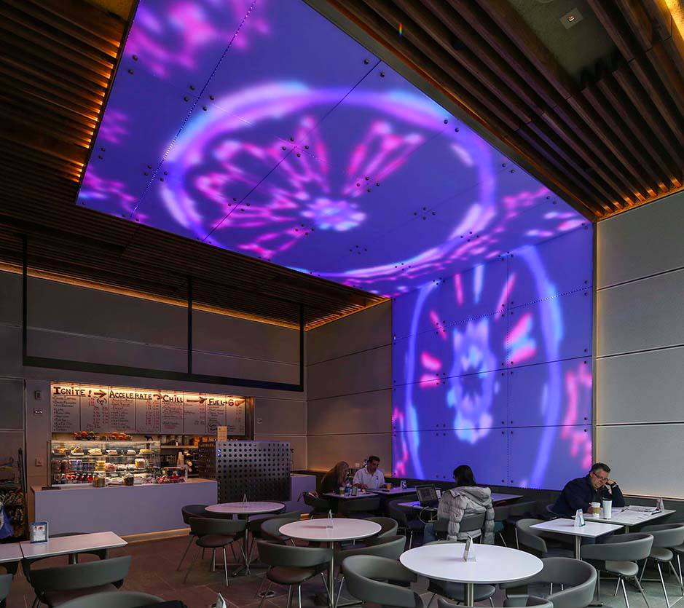
The Ground Café at the Yale University School of Engineering.
Source: Photo by Fly on the Wall Productions. http://yaleuniversity.tumblr.com/post/52822843963/the-yale-center-for-engineering-innovation-and.
Following the commercialization of LED technology, lighting has evolved beyond art substitutes. Philips additionally develops LED wallpaper, allowing walls to be instantaneously customizable as they are colored by light rather than paint. LED lighting has appeared in a multitude of unexpected niches—the automotive industry has adopted LEDs in car-door scuff plates and car-door projection light designs; LED showerheads and eyelashes also now exist. John Scribante expects LEDs to continue to evolve in terms of structure as well as efficiency, explaining that, “Organic LEDs and other exotic LED technologies are expensive today, but will be the future generations of LEDs.” Organic LEDs, or OLEDs, are digital displays in computer, television, and smart phone screens. With OLEDs, screens can be flexible in design, as well as thinner, lighter, brighter, and more efficient than original LCD screens.
These alternate uses for lighting will become essential for LED providers due to the prolonged lifespan of LEDs; unlike incandescent bulbs, LED consumers do not return as often to purchase new bulbs. After all LED retrofits are complete, revenue for LED providers will be provided mainly by new construction. In a 2012 global lighting market report by McKinsey & Company, the consulting firm projected LED growth rates to slow from 5% to 3% in 2016, highlighting a need for new uses of lighting.
Clean Energy Sourcing
In conclusion, although there is a threat for energy consumption rebound with new LED uses, it should be noted that LEDs are more efficient than their incandescent counterpart by a factor of ten, rather than a refrigerator’s efficiency improvement of a factor of four. In order to counteract the efficiency improvements that LEDs have accomplished, lighting would have to increase globally by ten fold compared to the era of fully incandescent lighting, making the chance of rebound unlikely.
While unlikely, the potential for rebound is an excellent reminder that energy efficiency, although considered a “fifth fuel,” is not actually a form of stand-alone energy. An LED light bulb, although it requires only 10% of an incandescent’s energy, still requires electricity. That electricity can be sourced from coal or petroleum, or it can be sourced renewably. The threat of rebound is an indication that despite all energy efficiency gains, generating energy renewably remains the core solution to global climate change.
Thankfully, LEDs are no longer an exorbitantly expensive alternative for carbon fluorescents or incandescents. As they have traditionally been the best lighting provider for the environment, LEDs are now also fiscally the best investment. For $2.49 a bulb, energy, carbon dioxide emissions, and water usage can be cut 39% to 90% depending on whether a consumer is switching from CFLs or incandescents. LED installation gains are immediate.

htp://www.bpa.gov/EE/Utility/research-archive/Documents/Momentum-Savings-Resources/LED_Market_Intelligence_Report.pdf
http://www.lumec.com/blog/index.php/2015/04/21/philips-sets-new-standard-for-60-watt-led-pricing-with-bulb-under-5-for-earth-day/
Data sources: LED: http://www.bpa.gov/EE/Utility/research-archive/Documents/Momentum-Savings-Resources/LED_Market_Intelligence_Report.pdf CFL lamp: http://camelcamelcamel.com/MaxLite-MLS13GUWW-11279-13-watt-Self-Ballast/product/B0026KZOXA?active=new&context=browse Incandescent (based on a 48-bulk pack, likely to be higher prices historically when purchased individually. No individual 60W lightbulb data was available): http://camelcamelcamel.com/GE-41026-48-60-Watt-865-Lumen-
http://www.maneriagraz.com/2014/09/05/moores-law-leds-haitzs-law/
https://www.energystar.gov/index.cfm?c=cfls.pr_cfls_about
http://electronics.howstuffworks.com/led1.htm
http://www.cree.com/News-and-Events/Cree-News/Press-Releases/2014/March/300LPW-LED-barrier
http://www.homedepot.com/catalog/pdfImages/5d/5d01f48f-0c87-4b05-86d4-d6d1c0876398.pdf
https://www.electricchoice.com/electricity-prices-by-state/
http://www.ledwaves.com/pages/led-calc (assuming $0.11/ kWh)
http://www.ledwaves.com/pages/led-calc (assuming $0.11/kWh)
http://investor.oriones.com/eventdetail.cfm?EventID=164195
Philips A19 LED: http://www.homedepot.com/p/Philips-60W-Equivalent-Soft-White-A19-LED-Light-Bulb-2-Pack-455576/205815532 TCP 60W Equivalent: http://www.homedepot.com/p/TCP-60W-Equivalent-Soft-White-2700K-A19-Dimmable-Omni-LED-Light-Bulb-L9ADO27K/205865500 Philips T2 Spiral CFL: http://www.homedepot.com/p/Philips-60W-Equivalent-Daylight-6500K-T2-Spiral-CFL-Light-Bulb-E-4-Pack-434399/203248911 Incandescent and Payback Period (assuming $0.11/kWh): http://www.ledwaves.com/pages/led-calc
http://www.ucsusa.org/clean_energy/our-energy-choices/energy-and-water-use/water-energy-electricity-overview.html#.VaxRESpViko
http://www.wscls.com/index.php/news/8-news/321-lighting-for-the-modern-day-warehouse-7
http://www.eia.gov/tools/faqs/faq.cfm?id=99&t=3
http://blueskymodel.org/kilowatt-hour
http://climateandcapitalism.com/wp-content/uploads/sites/2/2012/06/Burning-Our-Water.pdf
http://www.newyorker.com/magazine/2010/12/20/the-efficiency-dilemma
http://www.unep.org/climatechange/Portals/5/documents/global_transition_efficient_lighting.pdf
http://www.reuters.com/article/2011/11/05/us-china-light-bulbs-idUSTRE7A40MV20111105
http://energyblog.nationalgeographic.com/2013/12/31/u-s-phase-out-of-incandescent-light-bulbs-continues-in-2014-with-40-60-watt-varieties/
http://abcnews.go.com/blogs/politics/2011/12/congress-defunds-ban-on-incandescent-light-bulbs-but-doesnt-quite-save-them/
http://abcnews.go.com/blogs/politics/2011/12/congress-defunds-ban-on-incandescent-light-bulbs-but-doesnt-quite-save-them/
http://www.newyorker.com/magazine/2010/12/20/the-efficiency-dilemma
http://www.newyorker.com/magazine/2010/12/20/the-efficiency-dilemma
http://www.usa.lighting.philips.com/cases/cases/education/yale-ground-cafe.html
https://www.google.com/search?q=yale+led+cafe&es_sm=119&tbm=isch&tbo=u&source=univ&sa=X&ved=0CDoQsARqFQoTCKDjt6ix78YCFQJZPgodA14AZA&biw=1226&bih=786&dpr=0.9#imgrc=_
http://inhabitat.com/luminous-led-wallpaper-lends-a-low-energy-glow-to-any-room/
http://www.amazon.com/Fittings-Stainless-Steel-Plate-MERCEDES/dp/B00IZA1T7K/ref=sr_1_3?s=hi&ie=UTF8&qid=1437405455&sr=8-3&keywords=car+door+scuff+LED+mercedes
http://www.amazon.com/Wireless-Universal-Projection-Projector-Courtesy/dp/B00UMKNKFU/ref=sr_1_fkmr3_3?s=hi&ie=UTF8&qid=1437405277&sr=8-3-fkmr3&keywords=car+door+scuff+LED+mercedes
http://www.amazon.com/DragonPad-LED-SHOWER-ROMANTIC-LIGHTS/dp/B005AEZ93Y
http://inhabitat.com/7-weird-and-wonderful-uses-for-led-lighting-technology/
http://www.2012.smartlighting.org/pdf/MCKINSEY_LIGHTING_THE_WAY_AHEAD.pdf

